PFLAG Long Island

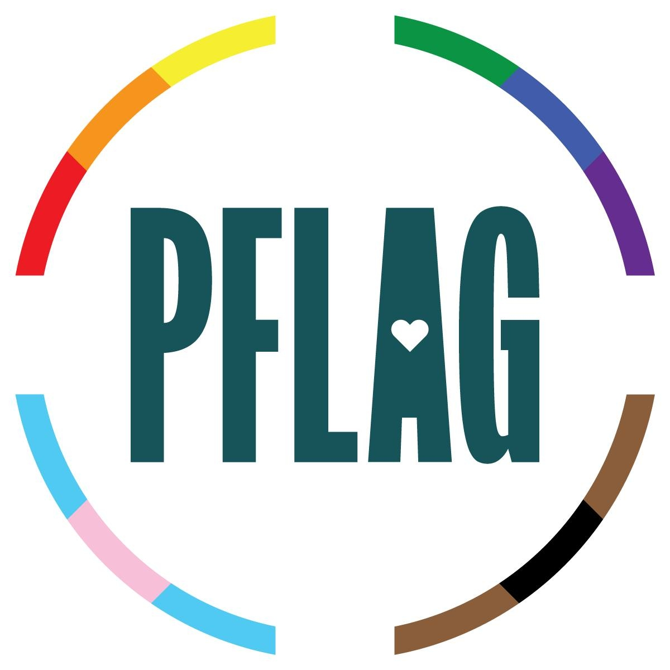

Helpline Services- www.pflagli.org
Facebook/Instagram- PFLAG Long Island

Dear PFLAG Long Island Supporter:

Please consider renewing your membership or making a contribution to further our efforts.
We are happy to accept small donations of $5, $10 or $15.

We count on your membership dues to support and help defray costs for meeting refreshments, postage, advertising, and other expenses in order for us to support families of LGBTQ+ individuals and help to keep them in loving relationships

The board of Pflag Long Island sincerely appreciates your help.
- - - - - - - - - - - - - - - - - - - - - - - - - - - - - - - - - - - - - - - - - - - - - - - - - - - - - - - - - - - - - -

PFLAG L.I. MEMBERSHIP APPLICATION

Date __________________

$ 35 Single Member ( ) $50 Family Member ( )
$ 75 Supporting Member ( ) $100 Silver Member ( )
$ 500 Gold Member ( )

I will not renew at this time but I am enclosing an additional tax deductible
contribution of: $_________

Make check payable to: PFLAG/LI, Inc.
P.O. Box 364
Jericho, NY 11753

Name ___________________________________________________

Address* ________________________________________________
City, State, Zip* ___________________________________________________

Phone* _______________________ Email* _________________________

